Technical Specification

QuizTest Project

一、Development Environment ：jdk 1.8 、H2 database

1. Project initialization and Project directory structure

1.Initializes the project database table structure

/*** create table ***/  
create table student(uid bigint auto_increment, uname varchar(50), upassword varchar(30),ulevel int(11),unumber varchar(30));  
create table STUDENTGRADE(sid bigint auto_increment,uid bigint,sgrade int(11),stotal int(11));  
create table QUESTION(qid bigint auto_increment, qcontent varchar(255),qtopics varchar(100),qdifficulty int(11),qtype int(11));  
create table MCQChoice(mid bigint auto_increment, mchoice varchar(100),mvalid boolean,qid bigint);  
create table OpenQuestion(oqid bigint auto_increment,oqtext varchar(4000),qid bigint);  
create table ANSWER(aid bigint auto_increment,qid bigint,atext varchar(255));  
create table QUIZ(id bigint auto_increment, name varchar(255));  
  
/*** Initialization Test User Logon Data 1: Administrator 2: Ordinary User ***/  
insert into student (uname,upassword,ulevel) values ('admin','123',1);  
insert into student (uname,upassword,ulevel,unumber) values ('front','123',2,141785);

/*** Initialize the test paper data and import the txt suffix file under SQL into the database using the command ***/  
INSERT INTO STUDENT ( SELECT * FROM CSVREAD('C:\Users\dell\Desktop\QuizTest\QuizTest\sql\student.txt ')) ;  
INSERT INTO ANSWER ( SELECT * FROM CSVREAD(' C:\Users\dell\Desktop \QuizTest\QuizTest\sql\answer.txt ')) ;  
INSERT INTO QUIZ ( SELECT * FROM CSVREAD(' C:\Users\dell\Desktop \QuizTest\QuizTest\sql\quiz.txt ')) ;  
INSERT INTO QUESTION ( SELECT * FROM CSVREAD(' C:\Users\dell\Desktop \QuizTest\QuizTest\sql\question.txt ')) ;  
INSERT INTO OpenQuestion ( SELECT * FROM CSVREAD(' C:\Users\dell\Desktop \QuizTest\QuizTest\sql\openquestion.txt ')) ;  
INSERT INTO MCQChoice ( SELECT * FROM CSVREAD(' C:\Users\dell\Desktop \QuizTest\QuizTest\sql\mcqchoice.txt ')) ;  
INSERT INTO STUDENTGRADE ( SELECT * FROM CSVREAD(' C:\Users\dell\Desktop \QuizTest\QuizTest\sql\studentgrade.txt ')) ;

2.Project directory structure

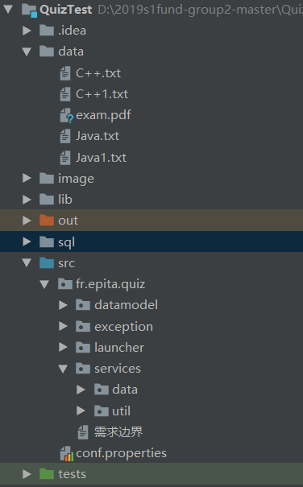

data:Inside the storage is the examination paper question and the examination result file

image:It's the background image

lib:Inside is the database connection and export PDF file jar package

sql:It contains database initialization statements and data files

src:It contains the program source code

tests:It contains test classes

inside of the src:

datamodel:It contains data model files

exception:It contains exception handling files

launcher:Inside is the boot screen

services:It contains database operations and utility files

1. GUI

1.Login

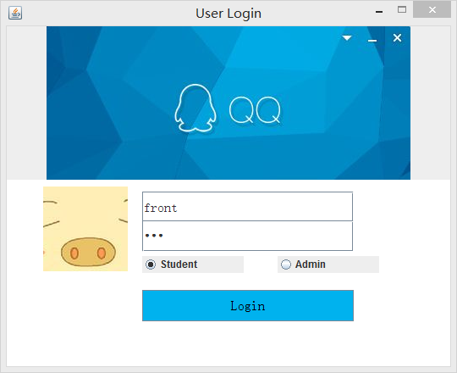

2.front-end

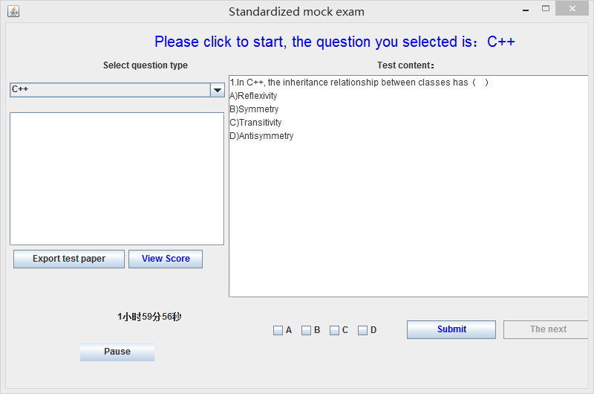

3.back-end

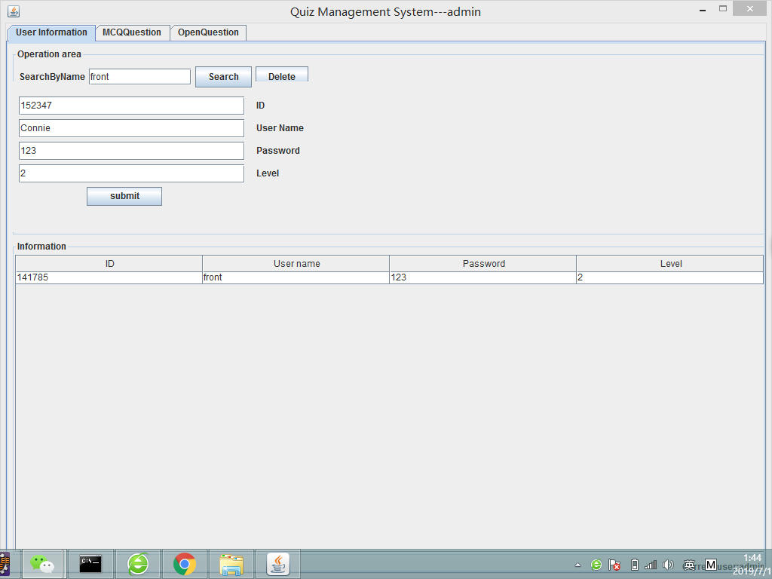

1. Functional specifications

Including front and back end, front end randomly generated papers for students to test, test results exported as PDF file, back end for teachers to manage multiple choice and open questions.

1. Login

LoginFrame class uses the checkLogin () and verifyLogin (String level, String name) method for the login user verification and calibration status, if the selected for students is a regular user login, the login successful test, if the choice is the super user login, for the teachers can enter after a successful login multiple-choice, student account information, open questions.

1. Front-end student examination

First, select the test type, then click start timing, the third pair of randomly generated questions in turn answer and submit the answer, the fourth and all questions after the answer can see the score, the fifth after viewing the score can export the test result information.

1. The above methods are based on the click event of the button, the itemStateChanged(ItemEvent e) method in FrontFrame class completes the corresponding logic, among which, buildExamFile() method in ExamQuestionJDBCDAO class randomly generates the paper topic, queryQuestionTopics() method obtains the topic of the question, and writeSimplePdf(String data) method in PDFReport class exports the paper Pdf file.
2. The back-end manages test questions

Student information management：You can query the relevant information of students according to their names, add student information, and select a single student record and delete it.

Multiple choice information management：You can query the related information of multiple choice questions according to the topic of multiple choice questions, you can also add information of multiple choice questions, and you can also select a single multiple choice question record and delete it.

Open question information management：You can query the relevant information of the open question according to the topic of the open question, and you can add the information of the open question, and you can also select a single open question record and delete it.

The above methods are based on button click events, the corresponding logic is completed by the actionPerformed(ActionEvent e) method in the AdminFrame class, where the insert(MCQQuestion MCQQuestion) method in the MCQQuestionJDBCDAO class inserts multiple-choice questions, and the delete(Question Question) method deletes multiple-choice questions. QueryMCQQuestionAllByName (Question Question) method according to the theme of the multiple choice questions.